Part Number: PTMZD-1M160-02

Kit Contents
Item # | Quantity Reqd. | Description
1 | 1 | Kit Bracket
2 | 1 | Armrest, Main
3 | 1 | Lower Base
4 | 2 | Bushing, Outer LH & RH
5 | 2 | Bushing, Inner LH & RH
6 | 1 | Adapter, Upper
7 | 4 | 6mm Flat Head Screws
8 | 2 | Cap, Side Right & Left
9 | 1 | Bolt, Carriage
10 | 1 | Locknut, Serrated Flange Hex
Additional Items Required For Installation
Item # | Quantity Reqd. | Description
1
2
Conflicts
None
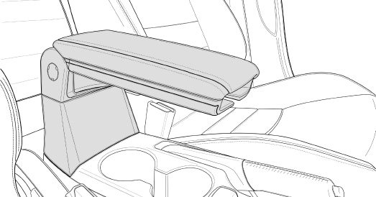
Recommended Tools
Personal & Vehicle Protection | Notes
Blanket/Seat Protection
Special Tools | Notes
Installation Tools | Notes
Ratchet
Torque Wrench | 0-30 ft-lbs (0-40 N-m)
Extension | 9”
Sockets | 10mm & 12mm
Universal Joint
Hex Socket | 3mm, Ball Drive
Utility Knife
Panel Removal Tool
Tape | Removable (i.e. masking)
Special Chemicals | Notes
General Applicability
All iA models
Recommended Sequence of Application
Item # | Accessory
1
2
*Mandatory
Vehicle Service Parts (may be required for reassembly)
Item # | Quantity Reqd. | Description
1
2
3
Legend
STOP: Damage to the vehicle may occur. Do not proceed until process has been complied with.
OPERATOR SAFETY: Use caution to avoid risk of injury.
CAUTION: A process that must be carefully observed in order to reduce the risk of damage to the accessory/vehicle and to ensure a quality installation.
TOOLS & EQUIPMENT: Used in Figures calls out the specific tools and equipment recommended for this process.
REVISION MARK: This mark highlights a change in installation with respect to previous issue.
SAFETY TORQUE: This mark indicates that torque is related to safety.

Care must be taken when installing this accessory to ensure damage does not occur to the vehicle. The installation of this accessory should follow approved guidelines to ensure a quality installation.

These guidelines can be found in the "Accessory Installation Practices" document.

This document covers such items as:-
- Vehicle Protection (use of covers and blankets, cleaning chemicals, etc.).
- Safety (eye protection, rechecking torque procedure, etc.).
- Vehicle Disassembly/Reassembly (panel removal, part storage, etc.).
- Electrical Component Disassembly/Reassembly (battery disconnection, connector removal, etc.).

Please see your Toyota dealer for a copy of this document.

Disassemble the Center Console.
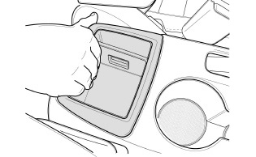
  - Firmly grip and pull up the storage bin to remove it (Fig. 1-1).
Fig. 1-1
  - Turn the storage cup over to expose the white clips, two on the back and one on each side.

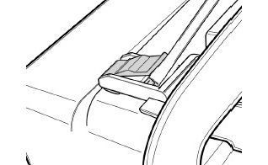
  - Use a panel removal tool to remove the two white clips on the back of the storage cup. Insert the tool under the clip face and press down into the groove (Fig. 1-2).
Fig. 1-2
Panel removal tool
NOTE: Keep the clips for reuse.

  - Remove the side clips from the storage cup.
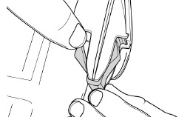
    - Press in with the index finger and thumb on the outside face of the white clip (Fig. 1-3).
Fig. 1-3

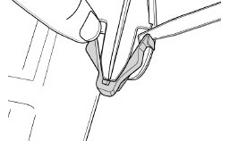
    - While pressing on the face of the clip, use a panel removal tool to catch the inside of the clip and slide it off (Fig. 1-4).
Fig. 1-4
Panel removal tool
NOTE: The clips will break if subjected to extreme bending.
NOTE: Keep the clips for reuse.

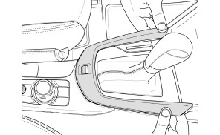
  - Lift up from the corner edges of the gear selector bezel around the shift lever and remove it (Fig. 1-5).
Fig. 1-5

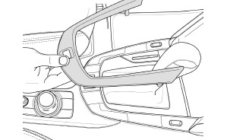
  - Use both hands to remove the gear selector bezel from the tab inserts (Fig. 1-6).
Fig. 1-6

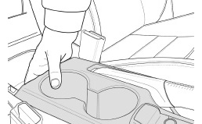
  - Firmly grip underneath the rear side of the cup holder panel and pull up to remove it (Fig. 1-7). Release the part and guide it through the parking brake lever cutout.
Fig. 1-7

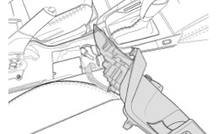
  - Do not disconnect the panel, set it aside safely against the passenger seat on the floor (Fig. 1-8). Protect the part from damage.
Fig. 1-8

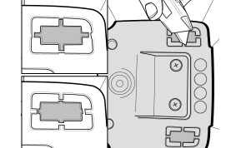
  - Use a knife to cut out the tabs in the inner main console (Fig. 1-9).
Fig. 1-9
Utility knife
CORRECT ✓
INCORRECT ✗
NOTE: Cut on the outer edge of the tab (Fig. 1-9).

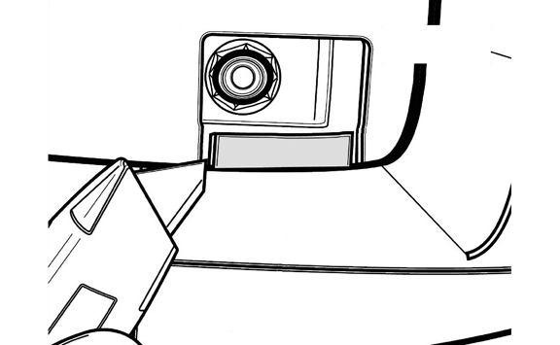
  - Use a knife to cut a square pattern and score towards the outer walls (Fig. 1-10). Push down on the cut plastic and remove it to expose the 10mm hex nuts.
Fig. 1-10
Utility knife
SCORE
SCORE
SCORE

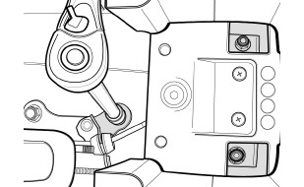
  - Remove the 10mm hex nuts (Fig. 1-11). Keep them for reuse.
Fig. 1-11
10mm & 12mm sockets, ratchet & extension
10mm
12mm
10mm
  - Remove the 12mm bolt (Fig. 1-11). Keep it for reuse.

Install the Armrest Bracket.
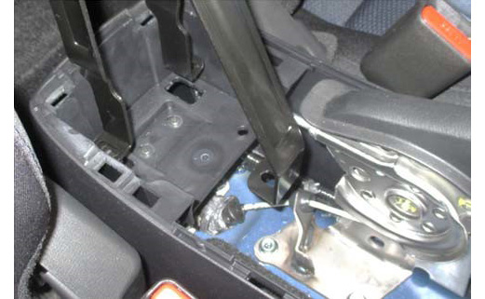
  - Insert the armrest bracket legs into the slots (Fig. 2-1).
Fig. 2-1
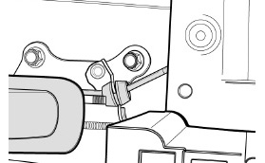
NOTE: Use caution when installing the bracket, as it sits in close proximity to the parking brake cable (Fig. 2-2).
Fig. 2-2

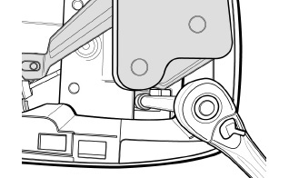
  - Reinstall the two 10mm hex nuts removed in Step 1(k) (Fig. 2-3).
Fig. 2-3
10mm socket, torque wrench & extension
10mm
Torque: 8 ft-lbs (10.8 N-m)

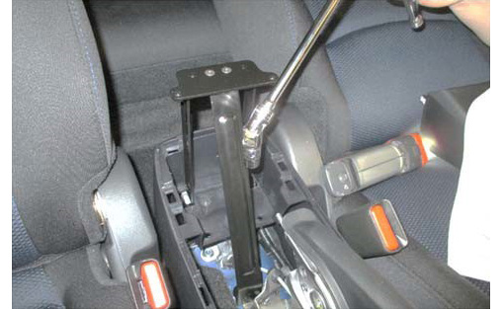
  - Reinstall the 12mm bolt removed in Step 1(l) (Fig. 2-4).
Fig. 2-4
12mm socket, universal joint, extension & torque wrench
12mm
Torque: 29 ft-lbs (39.3 N-m)
NOTE: The bracket leg hides the bolt head. A universal joint is required along with a short 12mm socket.

Install the Lower Base.
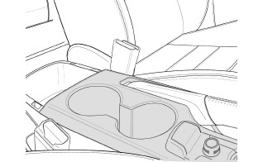
  - Replace the cup holder panel removed in Step 1(g) (Fig. 3-1). Ensure all pieces are securely fastened in place.
Fig. 3-1

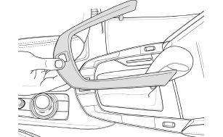
  - Replace the gear selector bezel removed in Step 1(f) (Fig. 3-2). Ensure the tabs enter the slots and is securely fastened in place.
Fig. 3-2

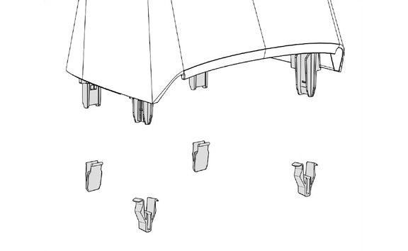
  - Install the white clips removed in Steps 1(c) and 1(d) to the lower base (Fig. 3-3).
Fig. 3-3
NOTE: The clips should snap into place with an audible sound.

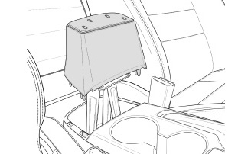
  - Insert the lower base over the armrest bracket and push it down firmly to snap all four tabs into the wall openings (Fig. 3-4).
Fig. 3-4
  - Test the lower base fit by slightly wiggling it to ensure it’s been properly installed.

Install the Upper Adapter.
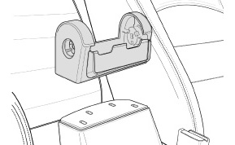
  - Insert the upper adapter onto the base lower (Fig. 4-1).
Fig. 4-1

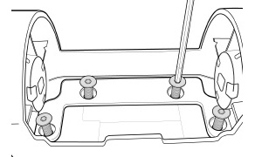
  - Use a 3mm ball-drive hex socket to install the four screws (Fig. 4-2).
Fig. 4-2
3mm ball-drive socket & torque wrench
Torque: 7 ft-lbs (9.5 N-m)

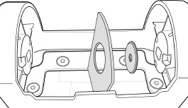
  - Insert the driver side inner shield and driver side outer bushing into the fitted adapter space (Fig. 4-3). The textured sides should be visible on the outside.
Fig. 4-3

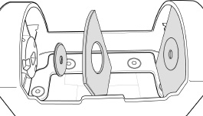
  - Insert the passenger side inner shield and passenger side outer bushing into the fitted adapter space (Fig. 4-4). The textured sides should be visible on the outside.
Fig. 4-4

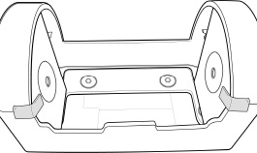
  - Affix removable tape to both the passenger side and driver side shields (Fig. 4-5).
Fig. 4-5

Install the Armrest.
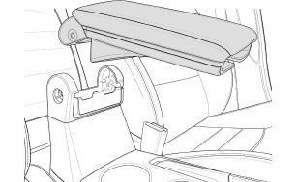
  - Insert the armrest into the adapter (Fig. 5-1). Position it so the holes are aligned for the carriage bolt.
Fig. 5-1

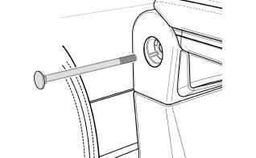
  - Insert the carriage bolt with the head of the bolt on the passenger side, through the shields, adapter, and armrest, until it reaches the other side (Fig. 5-2).
Fig. 5-2
NOTE: Ensure that the square neck locates into the square hole in the upper adapter on the passenger side.

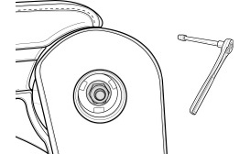
  - Use a 12mm socket to tighten the serrated-flange, hex locknut onto the threaded side of the bolt (Fig. 5-3).
Fig. 5-3
12mm socket & torque wrench
Torque: 3 ft-lbs (4 N-m)

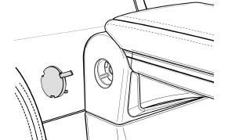
  - Install the caps (right & left) into the adapter, covering the bolt and hex locknut openings (Fig. 5-4).
Fig. 5-4

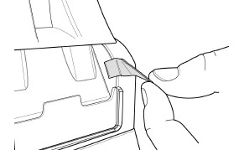
  - Lift the armrest and remove the two strips of tape from the inner shields (Fig. 5-5).
Fig. 5-5

Accessory Function Checks

Vehicle Function Checks

Vehicle Appearance Check
After accessory installation and removal of protective cover(s), perform a visual inspection.

Ensure no damage (including scuffs and scratches) was caused during the installation process.
(For PPO installations, refer to TMS Accessory Quality Shipping Standard.)

